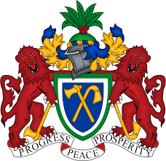
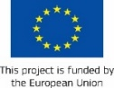

EXTENSION OF APPLICATIONS FOR ITC-SDF MINI-LOANS

Young Gambians are still experiencing difficulties in accessing financing. To bridge this gap, ITC has in collaboration with the Social Development Fund (SDF) developed a microfinance scheme that meets the needs of young entrepreneurs, the miniloan scheme.

Since October 2018, this scheme offers loan products with a reduced level of collateral and interest rates to young entrepreneurs across The Gambia and has resulted in unlocking GMD 11,485,400 of private capital for youth-owned businesses. The Mini-Loans Scheme aims at facilitating the acquisition of small machinery and equipment, acquisition of new premises, improvement and expanding of existing premises, and working capital for young entrepreneurs desiring to grow their businesses and already established small-scale businesses. The target beneficiaries for the scheme are young entrepreneurs between 18 and 35 years of age who have successfully completed a course or programme on skills, entrepreneurship or business management.
The average loan amount per beneficiary is GMD 150,000 ($3,000). The amount of financing to a single beneficiary is dependent on the application assessment and business plan proposed but will not exceed GMD 500,000 ($10,000). The loan term will be a maximum period of 12 months and a minimum period of 6 months per loan cycle. A maximum annual interest rate of 10% be applied. In order to access the loan, entrepreneurs interested in working capital loans are expected to provide a collateral calculated at 75% of the amount of the loan, while for equipment acquisition loans the equipment itself will be considered as collateral until the loan is fully repaid.
The scheme has a specific window to create self-employment opportunities for youth in the commercial transport sector. Young Gambians who wish to purchase a tricycle to make transport efficient, safe and affordable will be supported through the loan scheme. For the period of loan repayment, the SDF will own the tuk tuk 7-seater and the youth will be required to make regular loan repayments based upon fare revenue generated by the tricycle. At the completion of the loan repayment (i.e. 12 months), the tricycle asset will be fully owned by the youth and will be transferred to their own name. Young Gambians can apply to drive full time a tricycle to growth and prosperity here – women are especially encouraged to apply: Youth Tricycle Initiative - Opportunity | YEP
Application forms are available online on both the YEP and the SDF websites, along with instructions on how to submit electronic and hardcopy applications. Applications are open and the maximum repayment cycle is extended until September 2022. For any enquiries on how to submit an application, entrepreneurs can contact Mr. Lamin Jobarteh, SDF Director of Operations (Tel. +220 4399963 or +220 4399964 | Email: info@sdfgambia.gm, lmfjobarteh@sdfgambia.gm).
The initiative is supported by the European Union through Youth Empowerment Project (YEP) implemented by the International Trade Centre (ITC) in close collaboration with the Government of The Gambia.
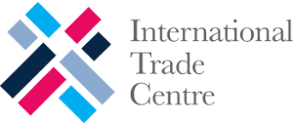
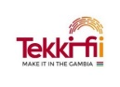
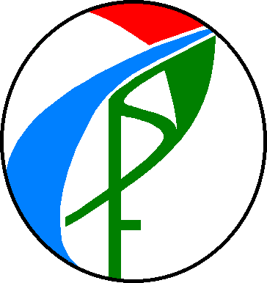

Social Development Fund

